

**YEAR 12 MATHEMATICS METHODS Test 1 2016**

Differentiation, Integration and Applications of both

## NAME: _________________________________________ Date: Tuesday 22 March 2016

**TEACHER: ____________________________**

|  |  |  |
| --- | --- | --- |
| **Non-calculator section:** | **23 minutes** | **23 marks** |
| **Calculator section:** | **27 minutes** | **27 marks** |
| **OVERALL:** | **50 minutes** | **50 marks** |

**INSTRUCTIONS:**

**Show FULL working Answer all questions on this test paper**

Questions or parts of questions worth more than two marks require working to be shown to receive full marks.

**Allowed: Maths Methods WACE formula sheets**

**Question 1: (5 marks)**

Calculate the area bounded by the function $y=x^{3}-8$ and the *x*-axis from *x* = 0 to *x* = 3

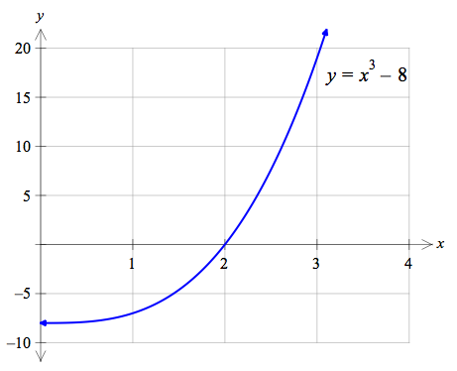

**Question 2: (5 + 5 = 10 marks)**

a. Differentiate the following (fully simplify all results, expressing answers with positive indices):

(i) $f\left(x\right)=\frac{2x-3}{5-4x}$ (ii) $y=\frac{2}{\sqrt{3x^{2}-4}}$

b. Evaluate the following integrals (fully simplify all results):

(i) $\int{8{\left(6x-3\right)}^{5}}dx$ (ii) $\int_{1}^{\sqrt{2}}{2x^{3}dx}$

**Question 3: (4 marks)**

The graph shows the function $y=f\left(x\right)$

Sketch the graphs of the first and second derivative directly below the original function.

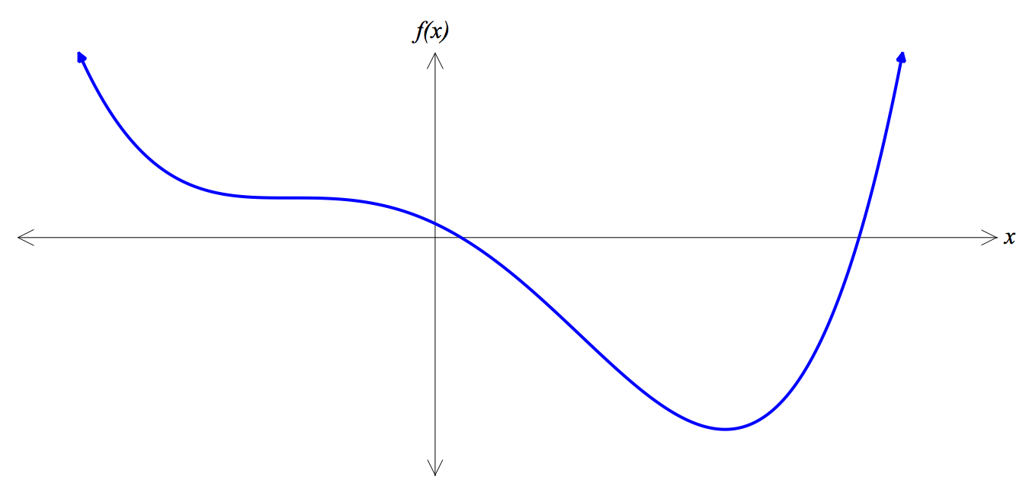

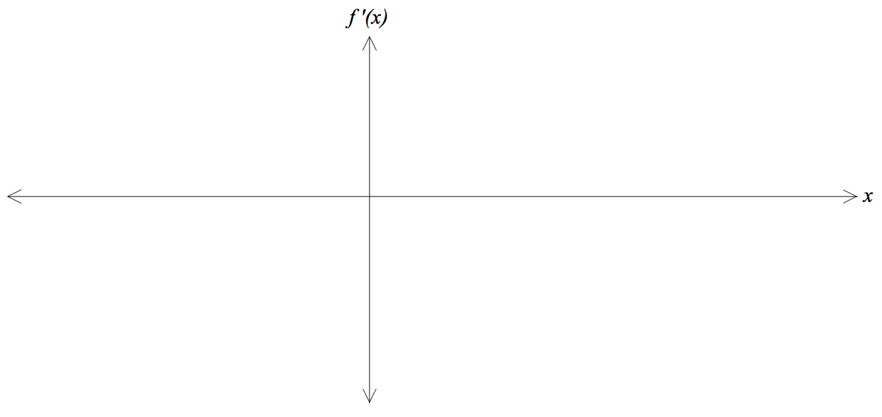

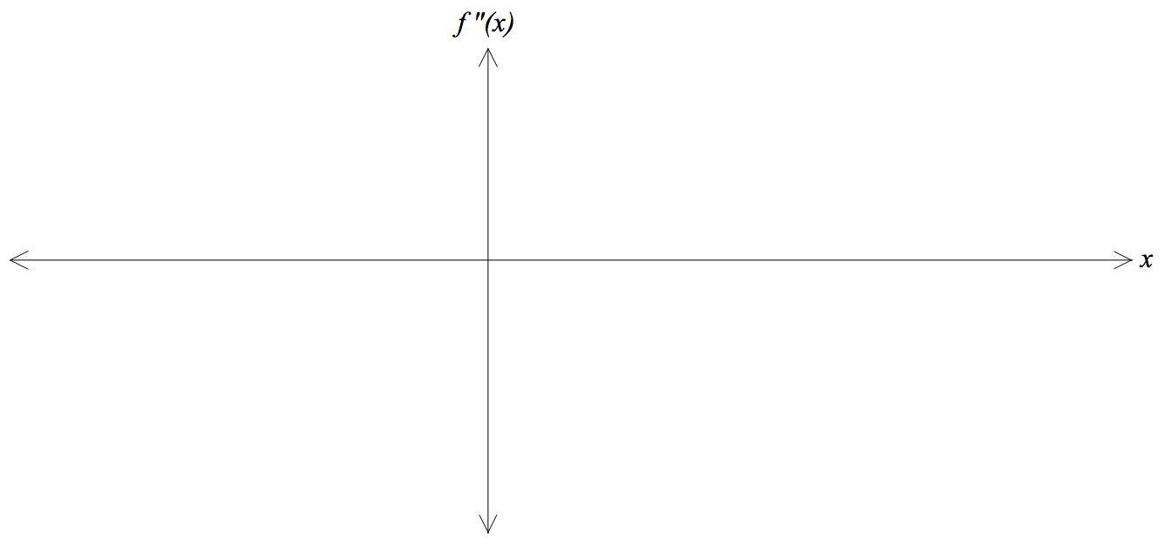

**Question 4: (4 marks)**

The following information relates to the graph $y=f\left(x\right)$ shown below:

* the area contained between the function and the *x*-axis from *x* = *b* to *x* = *c* is 15 units2.

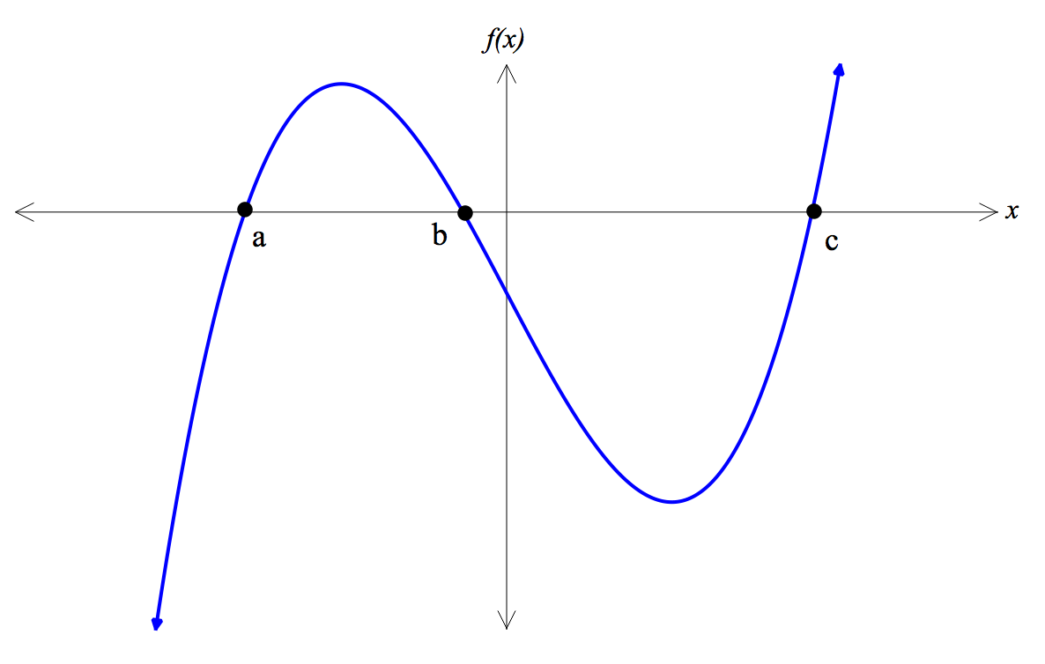

Calculate the following:

a. $\int_{a}^{b}{f\left(x\right)dx}$ b. $\left|\int_{a}^{c}{f\left(x\right)dx}\right|$

c. $\int_{a}^{c}{\left|f\left(x\right)\right|dx}$ d. $\int_{b}^{a}{f\left(x\right)dx}+ \int_{b}^{c}{f\left(x\right)dx}$

**End of non-calculator section – go back and check your working**



**YEAR 12 MATHEMATICS METHODS Test 1 2016**

Differentiation, Integration and Applications of both

## NAME: _________________________________________ Date: Tuesday 22 March 2016

**TEACHER: ____________________________**

|  |  |  |
| --- | --- | --- |
| **Non-calculator section:** | **23 minutes** | **23 marks** |
| **Calculator section:** | **27 minutes** | **27 marks** |
| **OVERALL:** | **50 minutes** | **50 marks** |

**INSTRUCTIONS:**

**Show FULL working Answer all questions on this test paper**

Questions or parts of questions worth more than two marks require working to be shown to receive full marks.

**Allowed: Maths Methods WACE formula sheets, 3 calculators, 1 A4 page of notes**

**Question 5: (2 marks)**

If the derivative of the cost function is $C '\left(x\right)=2x^{2}-130x+3000$, determine the extra cost (in $) incurred by producing 40 units of a product rather than 30 units.

**Question 6: (5 marks)**

The graph below shows the functions $y=x^{3}-4x$ and $y=3x^{2}$

**Using any method**, calculate the area contained between these two functions.

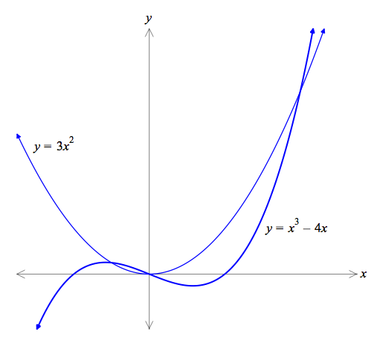

**Question 7: (5 marks)**

For the purposes of this question you need to know that a torus is a ‘doughnut’ shape. It consists of a large ring of radius *R*. The cross section of a torus is a circle of radius *r* (see diagrams).

|  |  |
| --- | --- |
|  |  |

The volume of a torus is $V=2π^{2}r^{2}R$

A rubber ring in the shape of a torus is being inflated. The **large radius (*R*) is FIXED at 30 cm**. Use the increments formula to determine the approximate increase in volume (to the nearest cubic centimetre) when the small radius (*r*) increases from 5cm to 5.1cm.

**Question 8: (1 + 1 + 2 + 2 + 2 = 8 marks)**

The velocity (in metres per second) of a projectile launched directly upwards from the surface of Mars is defined by the equation: $v\left(t\right)=200-3.75t$ where *t* is the time in seconds.

a. Calculate the initial launch speed of the projectile?

b. Determine an equation for the acceleration of the projectile $a\left(t\right)$

c. Determine an equation for the displacement of the projectile above the surface of Mars $x\left(t\right)$

d. Given that the velocity of the projectile is zero when it reaches its highest point, calculate the maximum height reached by the projectile.

e. For how many seconds is the projectile in the Mars atmosphere before it lands back on the surface? Answer to 1 decimal place.

**Question 9: (2 + 5 = 7 marks)**

|  |  |
| --- | --- |
| In Europe, soft drink cans tend to be quite small … a common size is 20 centiLitres which is the equivalent of 200 cm3. The company manufacturing the soft drink cans wishes to minimise the cost of production, which is determine by the amount of aluminium used.  The aluminium used for the side walls of the can is quite thin, only costing $0.0003 / cm2. Whereas the aluminium required for the circular top and base of the can needs to be thicker, and costs twice as much, $0.0006 / cm2. |  |

a. By showing clear methodical steps, demonstrate that the cost of a can (*C*) can be written as:

$$C=\frac{3πr^{2}}{2500}+\frac{3}{25r}$$

b. **Using your CAS and showing calculus techniques**, determine the dimensions of the cylinder (in centimetres) required to minimise the cost, and state the cost of this can. Give all answers accurate to **3 significant figures**.

**End of calculator section – go back and check your working**